Test Case: tc001_SPX_Dev5_Crear_Nueva_Linea_Requisicion_Spot_Tipo_Cobro_CC
Step 1 - Enter username and password and click to button Enter : Credentials Entered
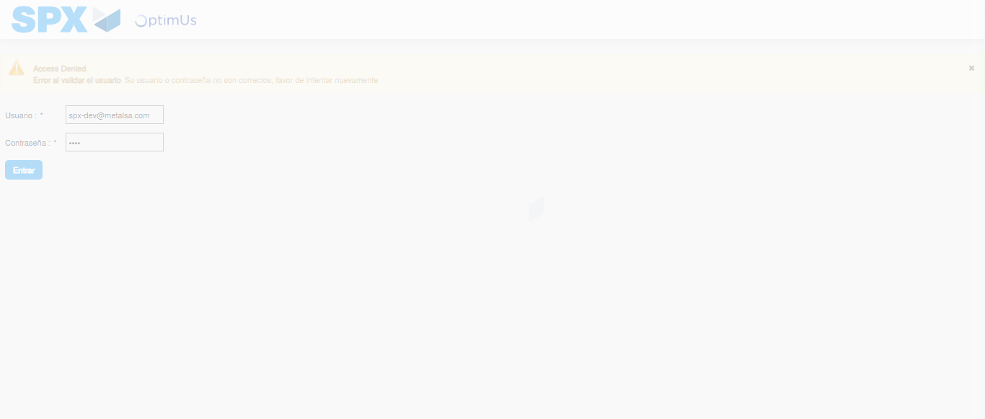Image file-name: QC_Testing-tc001_SPX_Dev5_Crear_Nueva_Linea_Requisicion_Spot_Tipo_Cobro_CC-nov. 28 2025, 09 54 25 a. m.

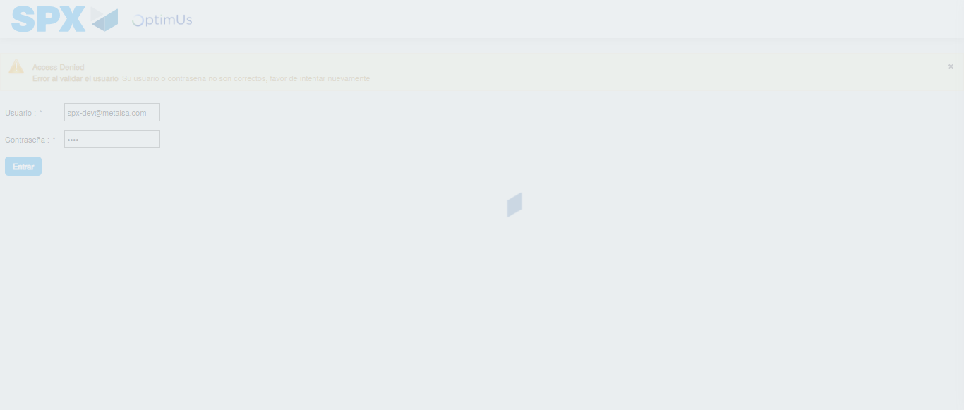Image file-name: QC_Testing-tc001_SPX_Dev5_Crear_Nueva_Linea_Requisicion_Spot_Tipo_Cobro_CC-nov. 28 2025, 09 54 26 a. m.

Step 2 - Select to UEN and Access to Spot Buy Requisitions : UEN Correctly selected and Correct access
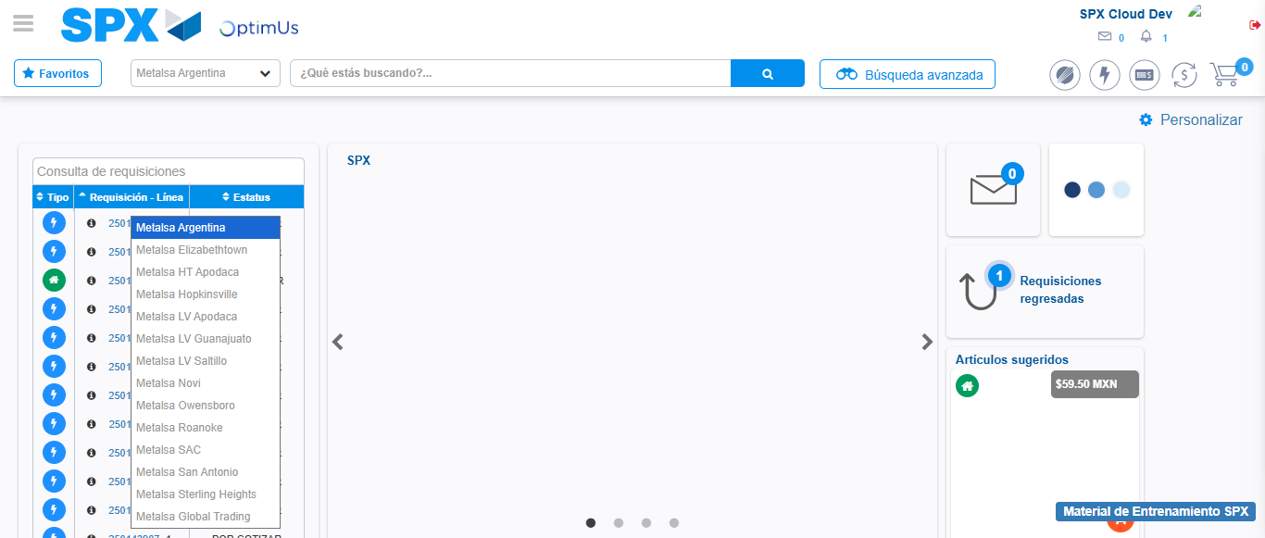Image file-name: QC_Testing-tc001_SPX_Dev5_Crear_Nueva_Linea_Requisicion_Spot_Tipo_Cobro_CC-nov. 28 2025, 09 54 29 a. m.

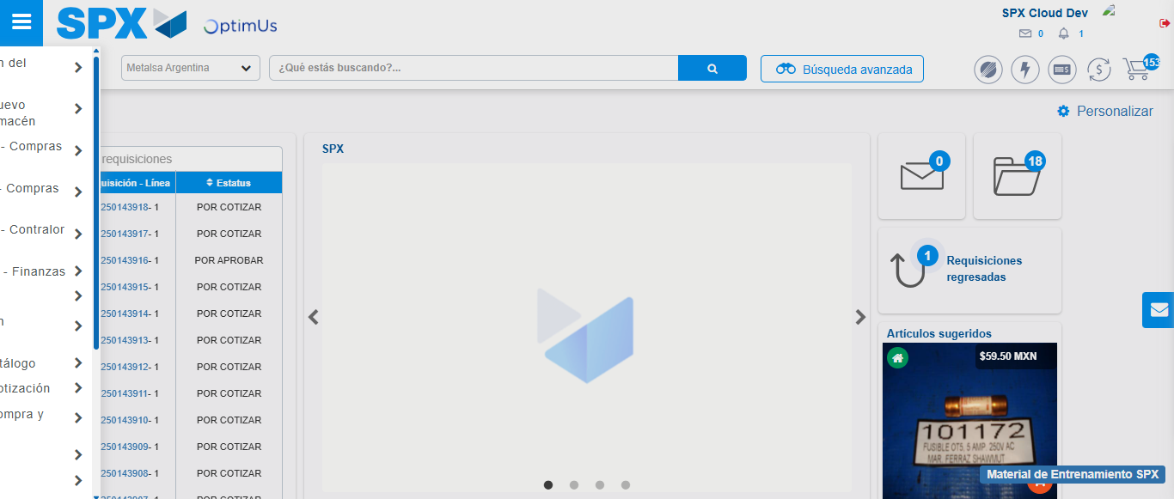Image file-name: QC_Testing-tc001_SPX_Dev5_Crear_Nueva_Linea_Requisicion_Spot_Tipo_Cobro_CC-nov. 28 2025, 09 54 30 a. m.

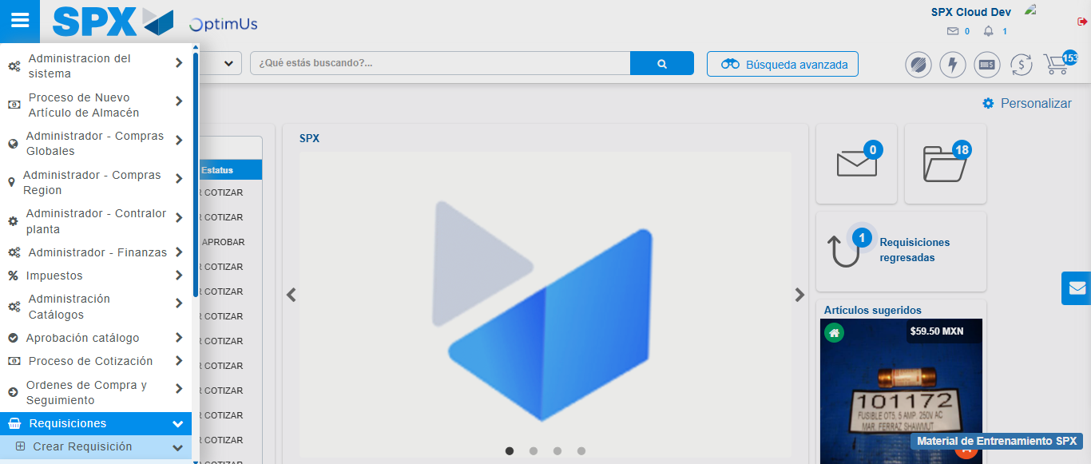Image file-name: QC_Testing-tc001_SPX_Dev5_Crear_Nueva_Linea_Requisicion_Spot_Tipo_Cobro_CC-nov. 28 2025, 09 54 31 a. m.

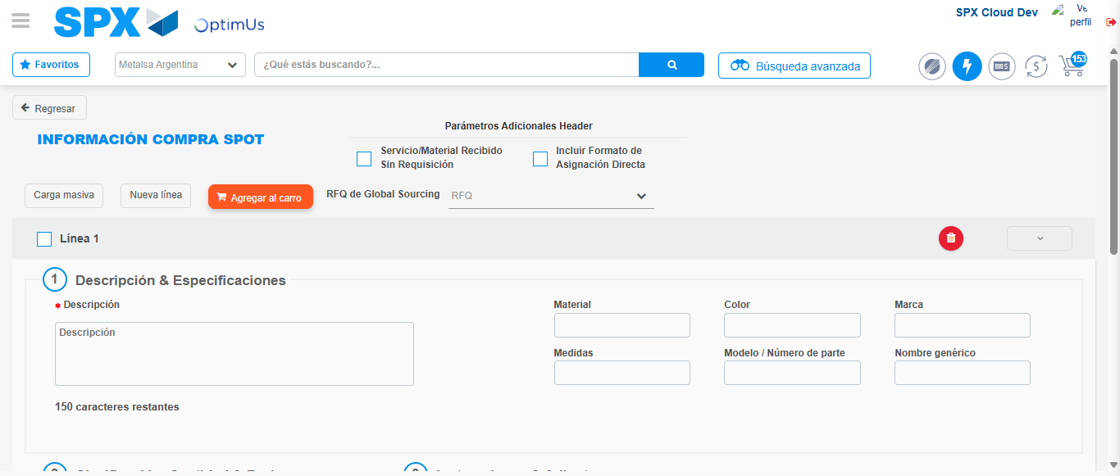Image file-name: QC_Testing-tc001_SPX_Dev5_Crear_Nueva_Linea_Requisicion_Spot_Tipo_Cobro_CC-nov. 28 2025, 09 54 35 a. m.

Step 3 - Data Capture Spot Buy Requisition: Data captured correctly
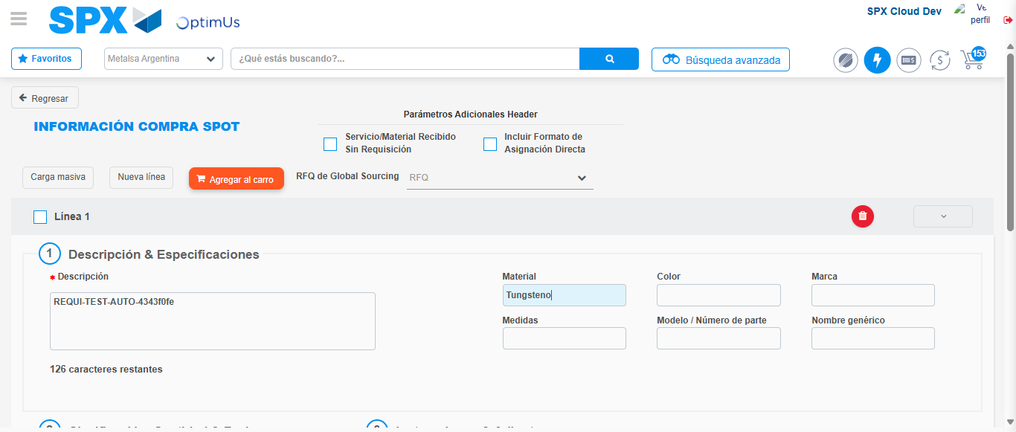Image file-name: QC_Testing-tc001_SPX_Dev5_Crear_Nueva_Linea_Requisicion_Spot_Tipo_Cobro_CC-nov. 28 2025, 09 54 36 a. m.

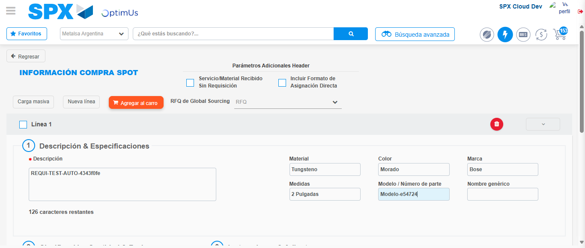Image file-name: QC_Testing-tc001_SPX_Dev5_Crear_Nueva_Linea_Requisicion_Spot_Tipo_Cobro_CC-nov. 28 2025, 09 54 37 a. m.

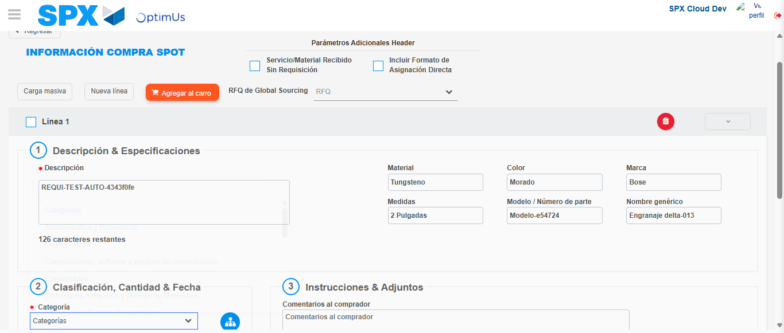Image file-name: QC_Testing-tc001_SPX_Dev5_Crear_Nueva_Linea_Requisicion_Spot_Tipo_Cobro_CC-nov. 28 2025, 09 54 38 a. m.

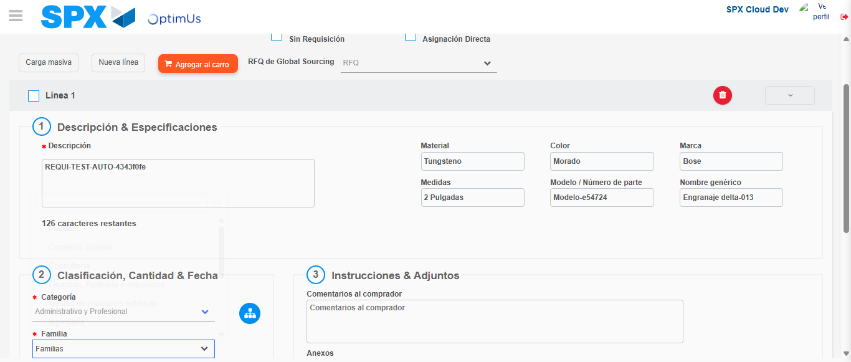Image file-name: QC_Testing-tc001_SPX_Dev5_Crear_Nueva_Linea_Requisicion_Spot_Tipo_Cobro_CC-nov. 28 2025, 09 54 39 a. m.

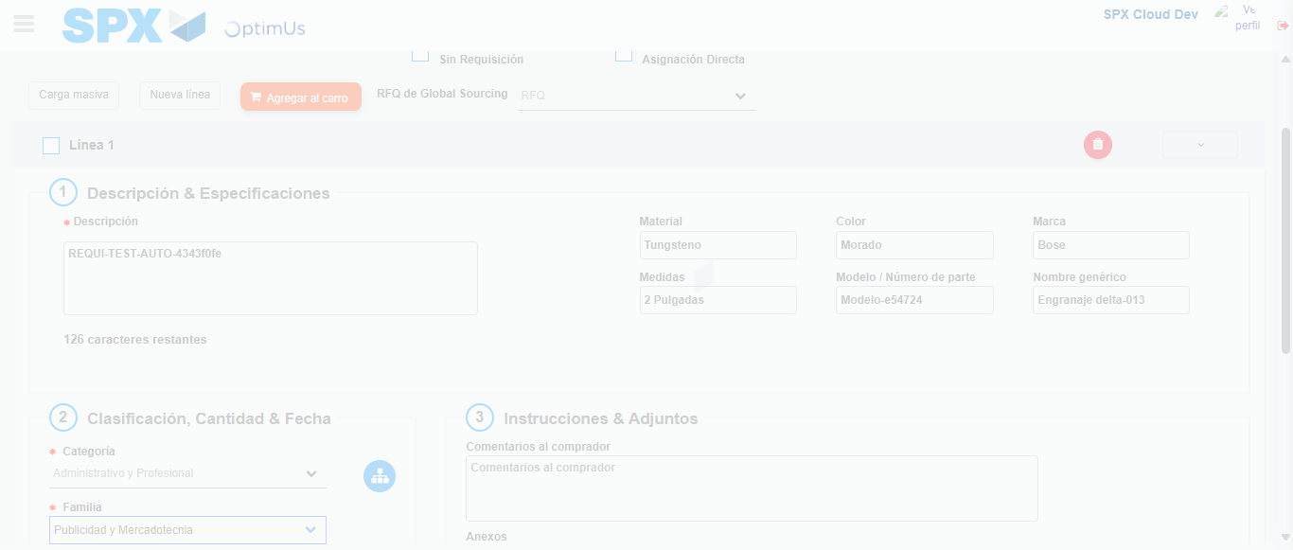Image file-name: QC_Testing-tc001_SPX_Dev5_Crear_Nueva_Linea_Requisicion_Spot_Tipo_Cobro_CC-nov. 28 2025, 09 54 40 a. m.

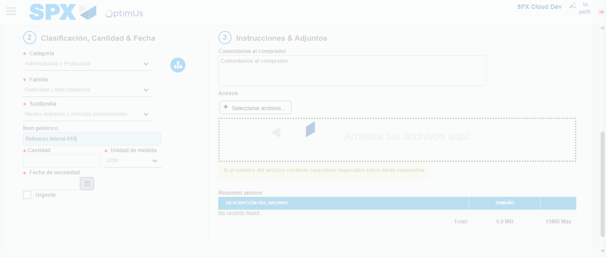Image file-name: QC_Testing-tc001_SPX_Dev5_Crear_Nueva_Linea_Requisicion_Spot_Tipo_Cobro_CC-nov. 28 2025, 09 54 41 a. m.

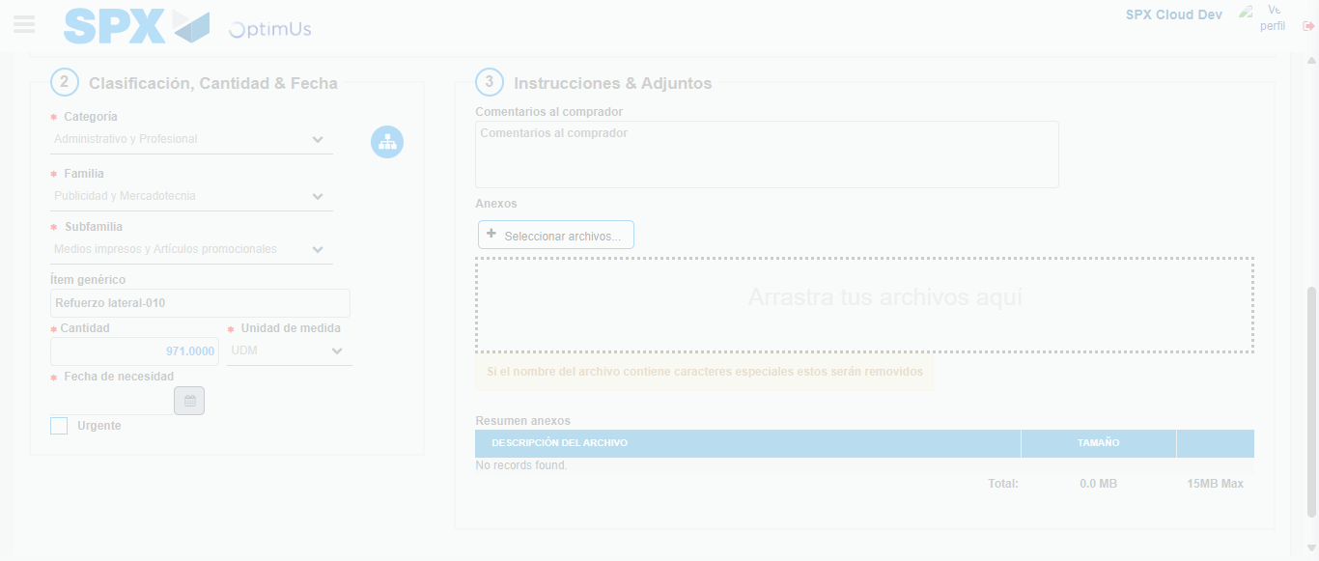Image file-name: QC_Testing-tc001_SPX_Dev5_Crear_Nueva_Linea_Requisicion_Spot_Tipo_Cobro_CC-nov. 28 2025, 09 54 42 a. m.

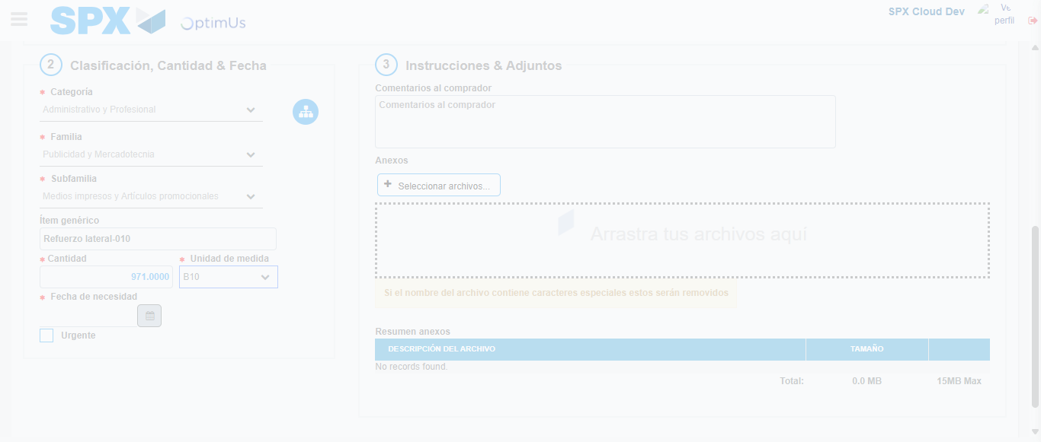Image file-name: QC_Testing-tc001_SPX_Dev5_Crear_Nueva_Linea_Requisicion_Spot_Tipo_Cobro_CC-nov. 28 2025, 09 54 43 a. m.

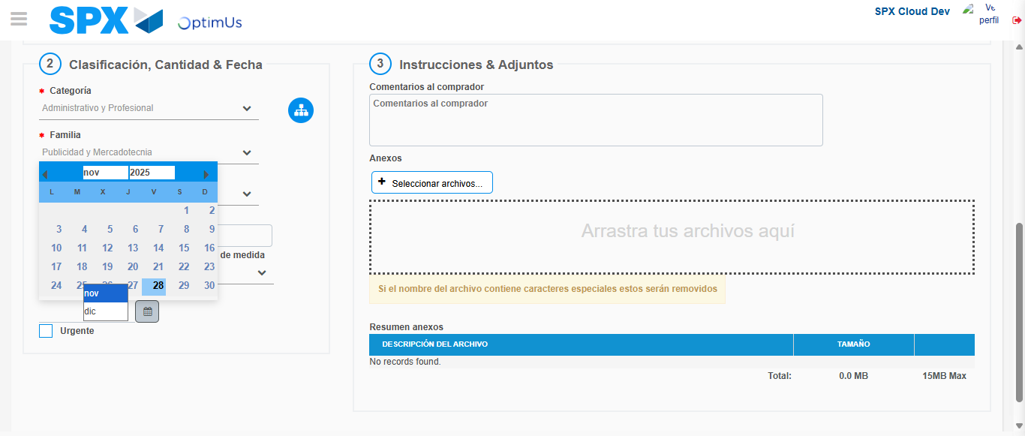Image file-name: QC_Testing-tc001_SPX_Dev5_Crear_Nueva_Linea_Requisicion_Spot_Tipo_Cobro_CC-nov. 28 2025, 09 54 45 a. m.

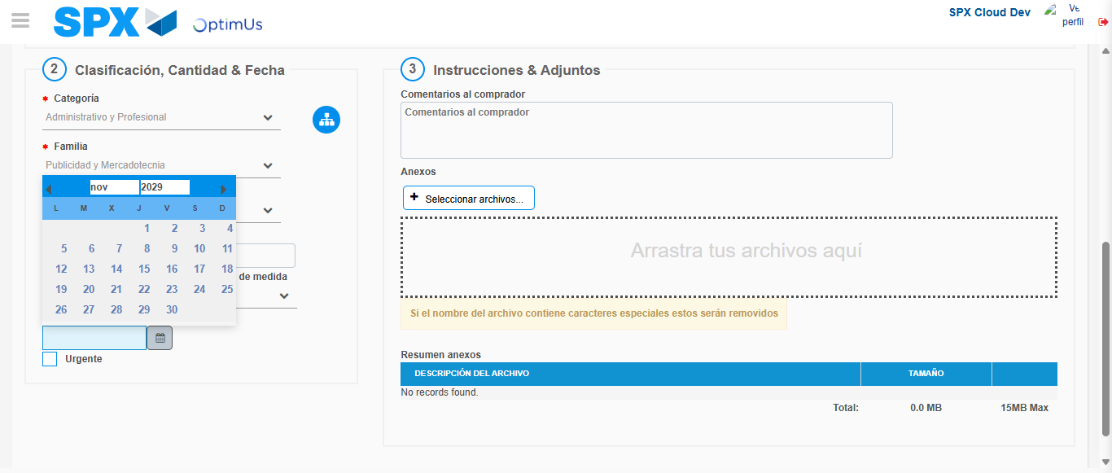Image file-name: QC_Testing-tc001_SPX_Dev5_Crear_Nueva_Linea_Requisicion_Spot_Tipo_Cobro_CC-nov. 28 2025, 09 54 46 a. m.

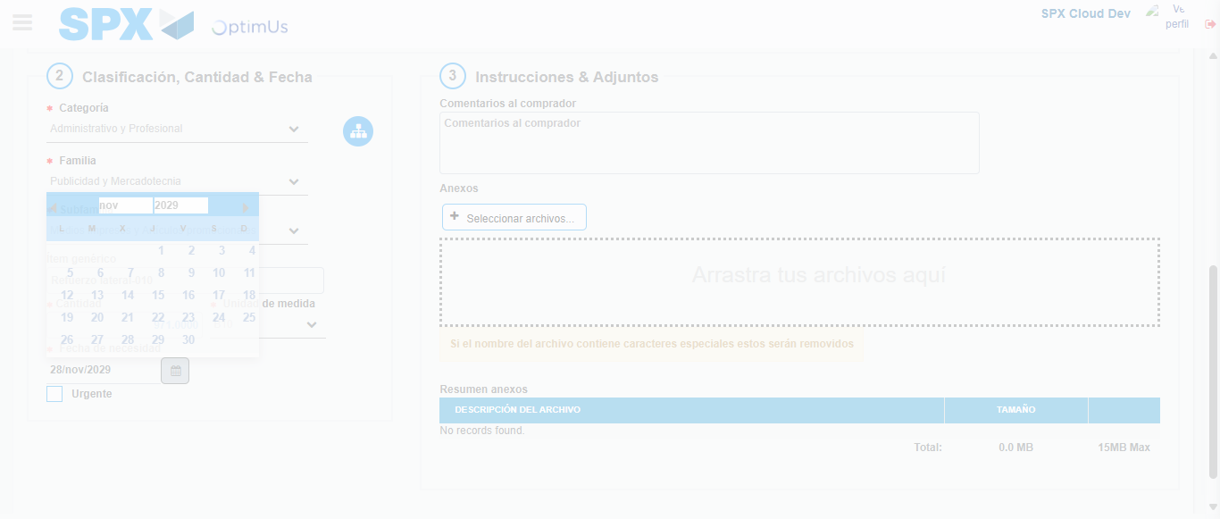Image file-name: QC_Testing-tc001_SPX_Dev5_Crear_Nueva_Linea_Requisicion_Spot_Tipo_Cobro_CC-nov. 28 2025, 09 54 47 a. m.

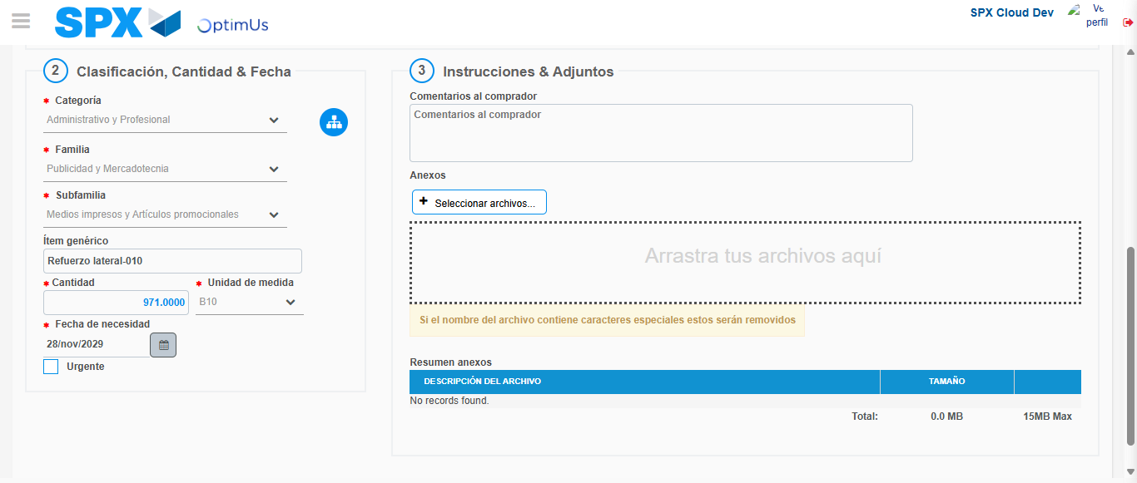Image file-name: QC_Testing-tc001_SPX_Dev5_Crear_Nueva_Linea_Requisicion_Spot_Tipo_Cobro_CC-nov. 28 2025, 09 54 51 a. m.

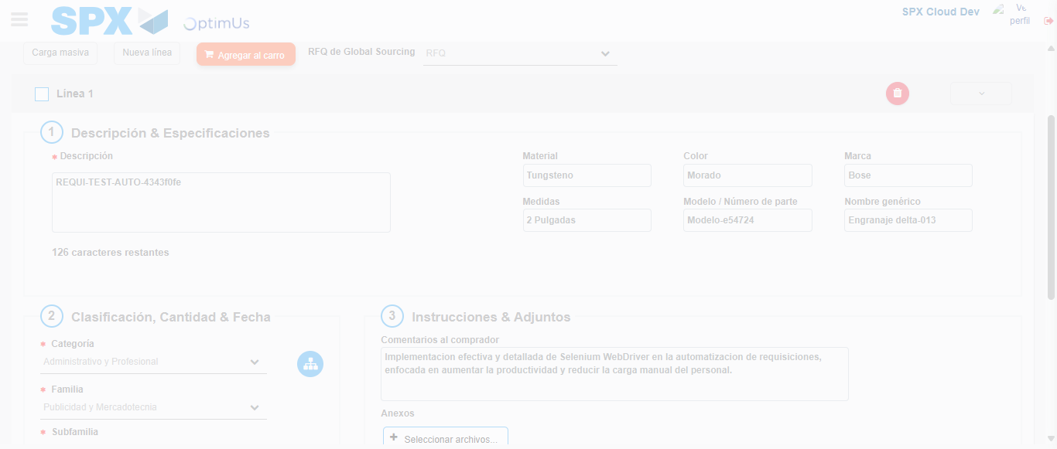Image file-name: QC_Testing-tc001_SPX_Dev5_Crear_Nueva_Linea_Requisicion_Spot_Tipo_Cobro_CC-nov. 28 2025, 09 54 52 a. m.

Step 4 - Add new line and data capture second line: Line add correctly
Image file-name: QC_Testing-tc001_SPX_Dev5_Crear_Nueva_Linea_Requisicion_Spot_Tipo_Cobro_CC-nov. 28 2025, 09 54 36 a. m.

Image file-name: QC_Testing-tc001_SPX_Dev5_Crear_Nueva_Linea_Requisicion_Spot_Tipo_Cobro_CC-nov. 28 2025, 09 54 37 a. m.

Image file-name: QC_Testing-tc001_SPX_Dev5_Crear_Nueva_Linea_Requisicion_Spot_Tipo_Cobro_CC-nov. 28 2025, 09 54 38 a. m.

Image file-name: QC_Testing-tc001_SPX_Dev5_Crear_Nueva_Linea_Requisicion_Spot_Tipo_Cobro_CC-nov. 28 2025, 09 54 39 a. m.

Image file-name: QC_Testing-tc001_SPX_Dev5_Crear_Nueva_Linea_Requisicion_Spot_Tipo_Cobro_CC-nov. 28 2025, 09 54 40 a. m.

Image file-name: QC_Testing-tc001_SPX_Dev5_Crear_Nueva_Linea_Requisicion_Spot_Tipo_Cobro_CC-nov. 28 2025, 09 54 41 a. m.

Image file-name: QC_Testing-tc001_SPX_Dev5_Crear_Nueva_Linea_Requisicion_Spot_Tipo_Cobro_CC-nov. 28 2025, 09 54 42 a. m.

Image file-name: QC_Testing-tc001_SPX_Dev5_Crear_Nueva_Linea_Requisicion_Spot_Tipo_Cobro_CC-nov. 28 2025, 09 54 43 a. m.

Image file-name: QC_Testing-tc001_SPX_Dev5_Crear_Nueva_Linea_Requisicion_Spot_Tipo_Cobro_CC-nov. 28 2025, 09 54 45 a. m.

Image file-name: QC_Testing-tc001_SPX_Dev5_Crear_Nueva_Linea_Requisicion_Spot_Tipo_Cobro_CC-nov. 28 2025, 09 54 46 a. m.

Image file-name: QC_Testing-tc001_SPX_Dev5_Crear_Nueva_Linea_Requisicion_Spot_Tipo_Cobro_CC-nov. 28 2025, 09 54 47 a. m.

Image file-name: QC_Testing-tc001_SPX_Dev5_Crear_Nueva_Linea_Requisicion_Spot_Tipo_Cobro_CC-nov. 28 2025, 09 54 51 a. m.

Image file-name: QC_Testing-tc001_SPX_Dev5_Crear_Nueva_Linea_Requisicion_Spot_Tipo_Cobro_CC-nov. 28 2025, 09 54 52 a. m.

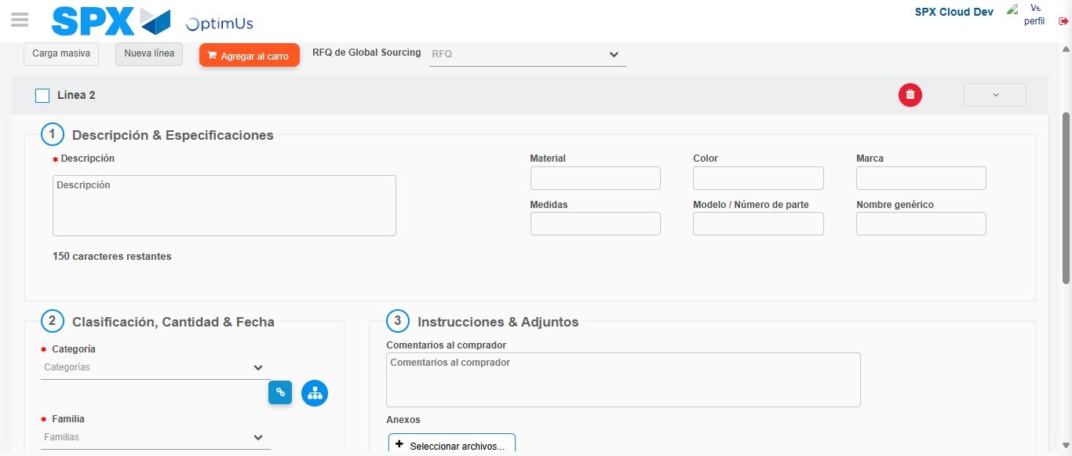Image file-name: QC_Testing-tc001_SPX_Dev5_Crear_Nueva_Linea_Requisicion_Spot_Tipo_Cobro_CC-nov. 28 2025, 09 54 55 a. m.

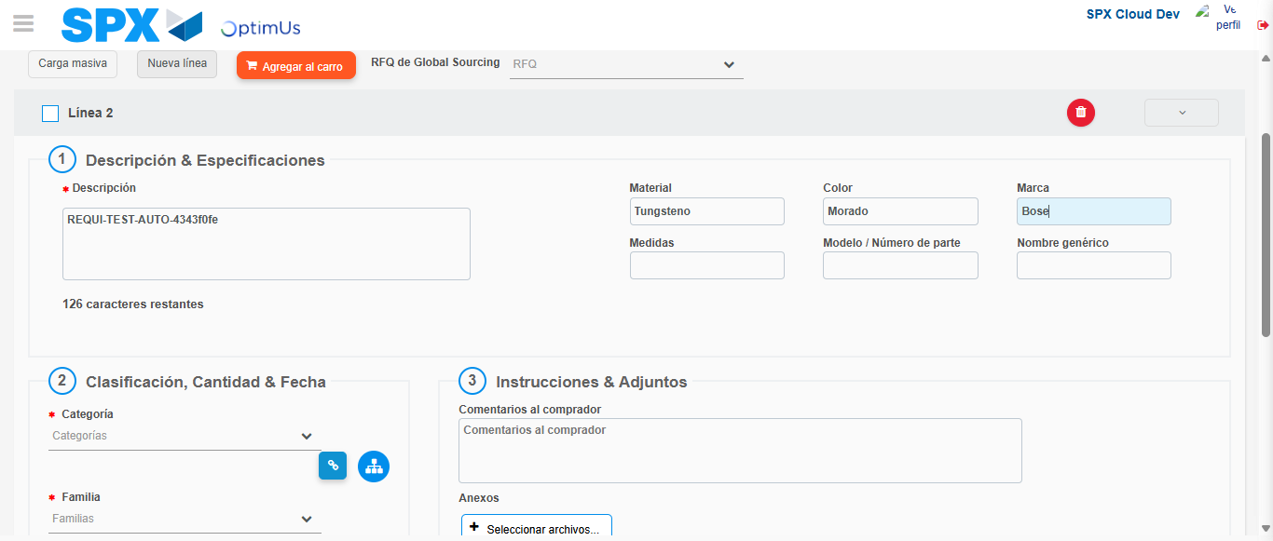Image file-name: QC_Testing-tc001_SPX_Dev5_Crear_Nueva_Linea_Requisicion_Spot_Tipo_Cobro_CC-nov. 28 2025, 09 54 56 a. m.

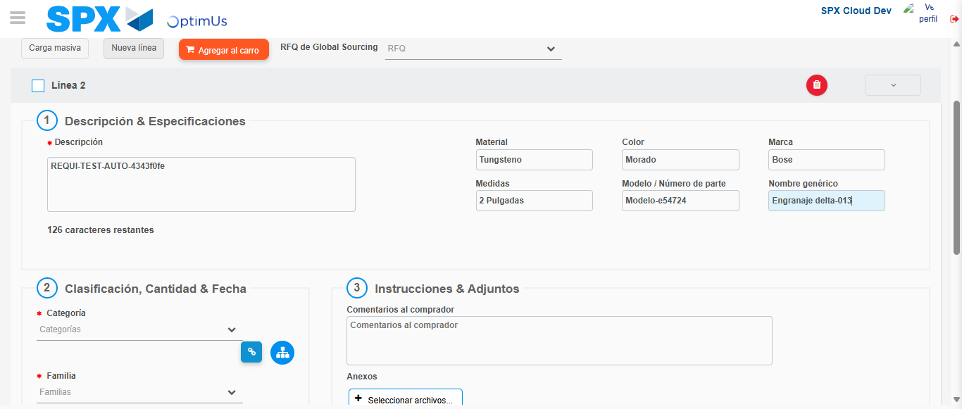Image file-name: QC_Testing-tc001_SPX_Dev5_Crear_Nueva_Linea_Requisicion_Spot_Tipo_Cobro_CC-nov. 28 2025, 09 54 57 a. m.

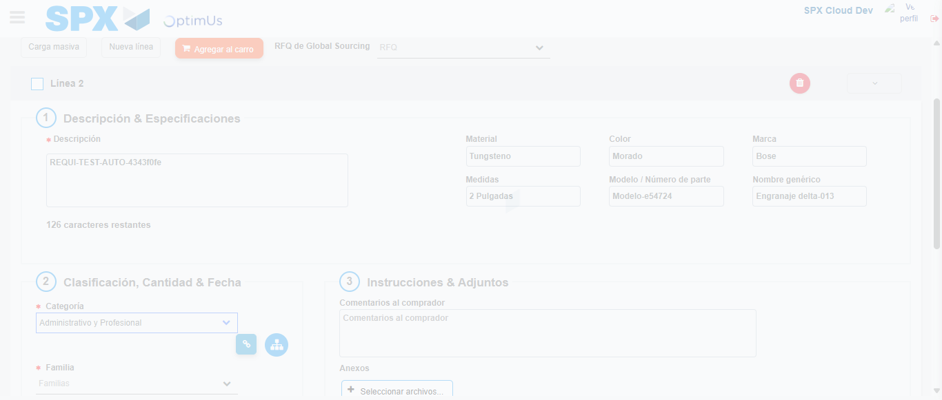Image file-name: QC_Testing-tc001_SPX_Dev5_Crear_Nueva_Linea_Requisicion_Spot_Tipo_Cobro_CC-nov. 28 2025, 09 54 58 a. m.

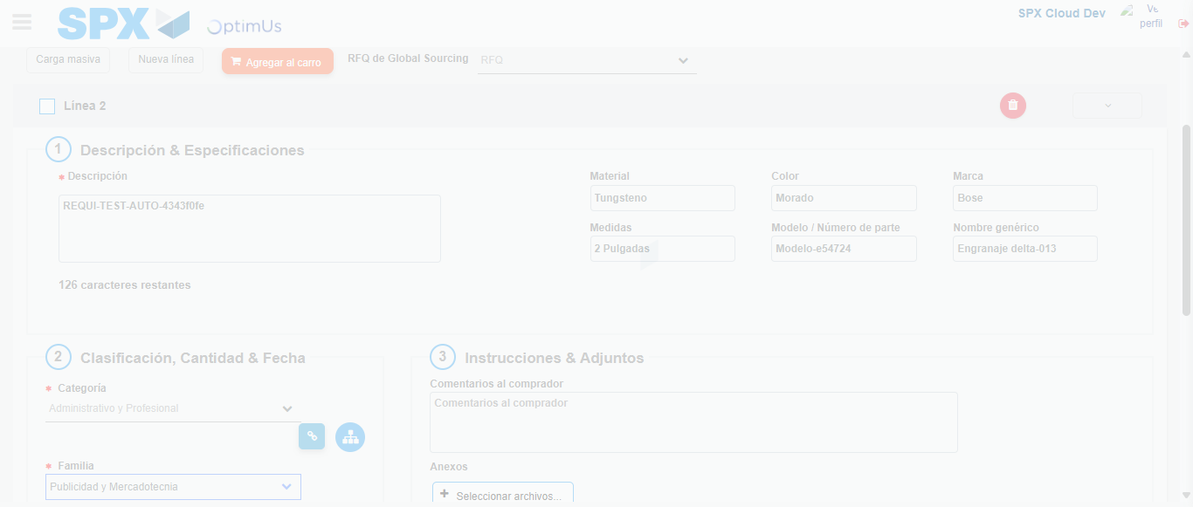Image file-name: QC_Testing-tc001_SPX_Dev5_Crear_Nueva_Linea_Requisicion_Spot_Tipo_Cobro_CC-nov. 28 2025, 09 54 59 a. m.

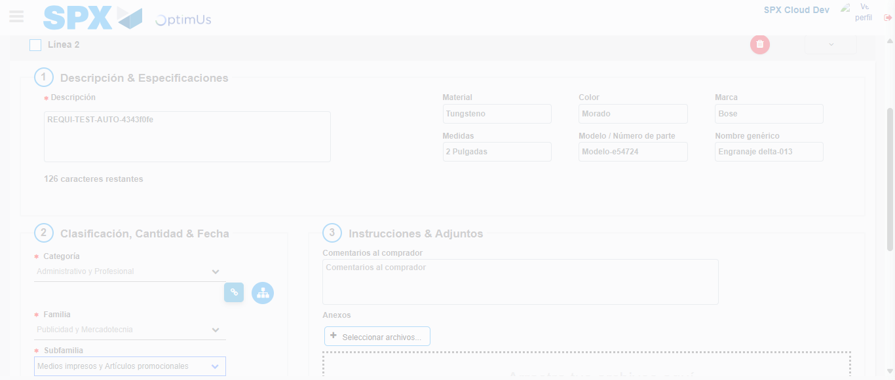Image file-name: QC_Testing-tc001_SPX_Dev5_Crear_Nueva_Linea_Requisicion_Spot_Tipo_Cobro_CC-nov. 28 2025, 09 55 00 a. m.

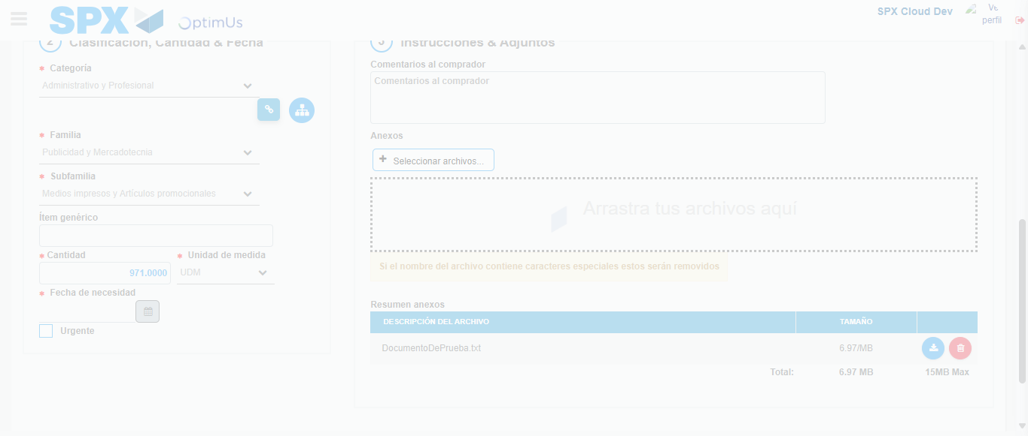Image file-name: QC_Testing-tc001_SPX_Dev5_Crear_Nueva_Linea_Requisicion_Spot_Tipo_Cobro_CC-nov. 28 2025, 09 55 01 a. m.

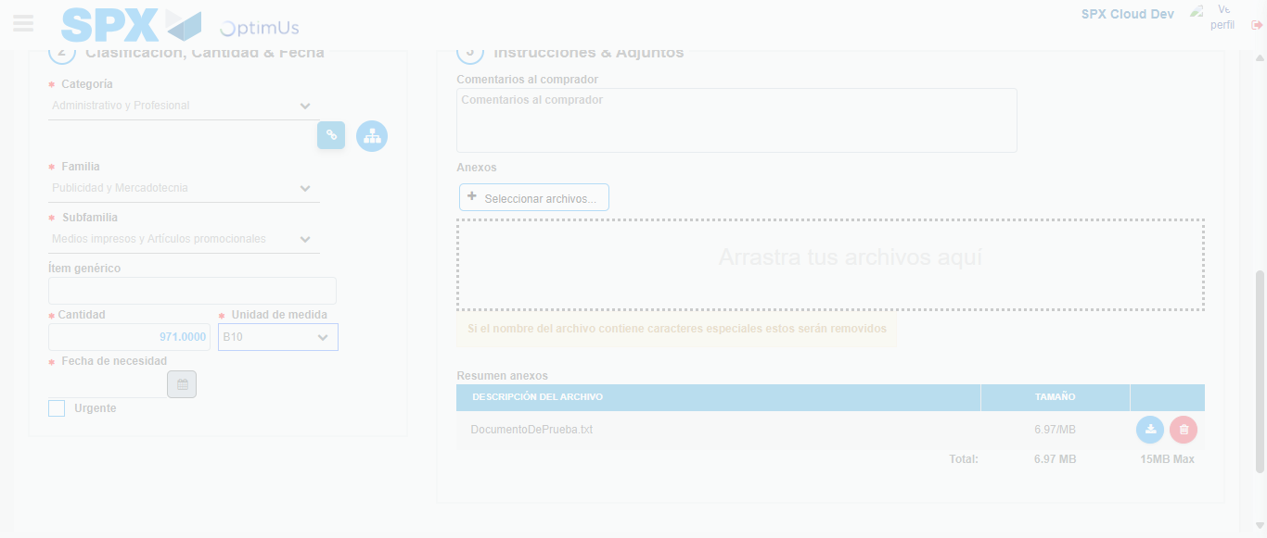Image file-name: QC_Testing-tc001_SPX_Dev5_Crear_Nueva_Linea_Requisicion_Spot_Tipo_Cobro_CC-nov. 28 2025, 09 55 02 a. m.

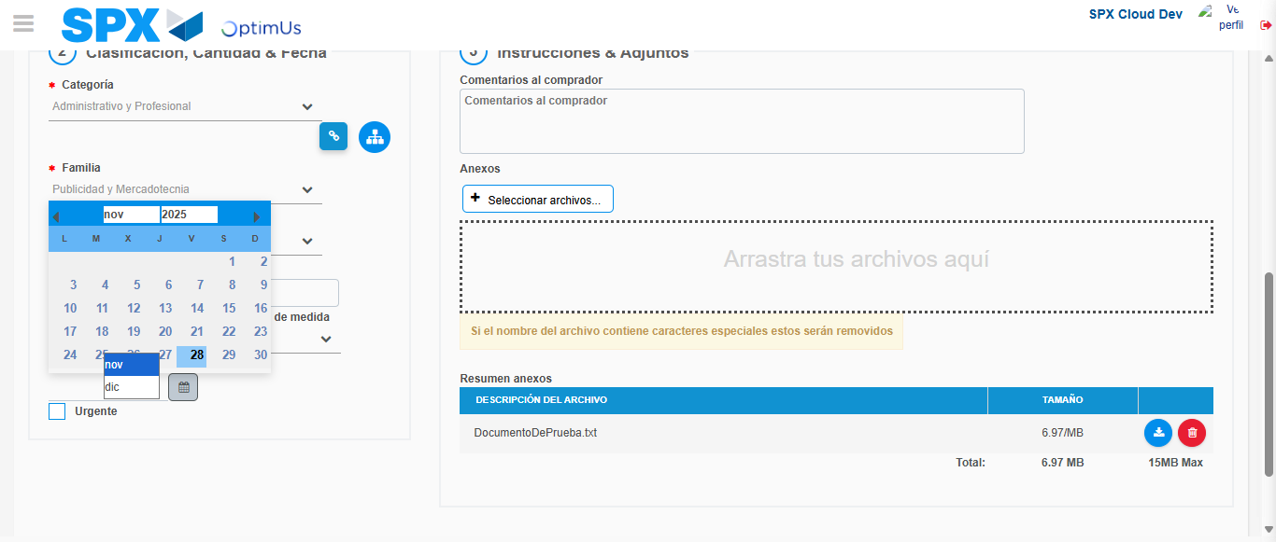Image file-name: QC_Testing-tc001_SPX_Dev5_Crear_Nueva_Linea_Requisicion_Spot_Tipo_Cobro_CC-nov. 28 2025, 09 55 03 a. m.

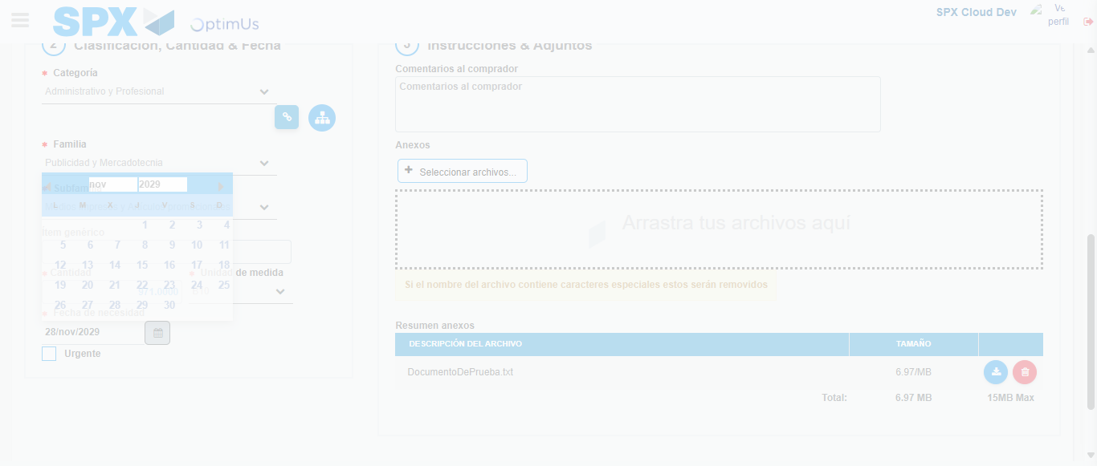Image file-name: QC_Testing-tc001_SPX_Dev5_Crear_Nueva_Linea_Requisicion_Spot_Tipo_Cobro_CC-nov. 28 2025, 09 55 04 a. m.

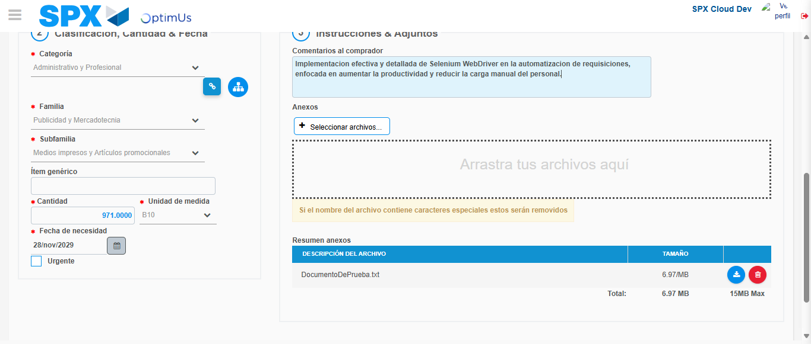Image file-name: QC_Testing-tc001_SPX_Dev5_Crear_Nueva_Linea_Requisicion_Spot_Tipo_Cobro_CC-nov. 28 2025, 09 55 05 a. m.

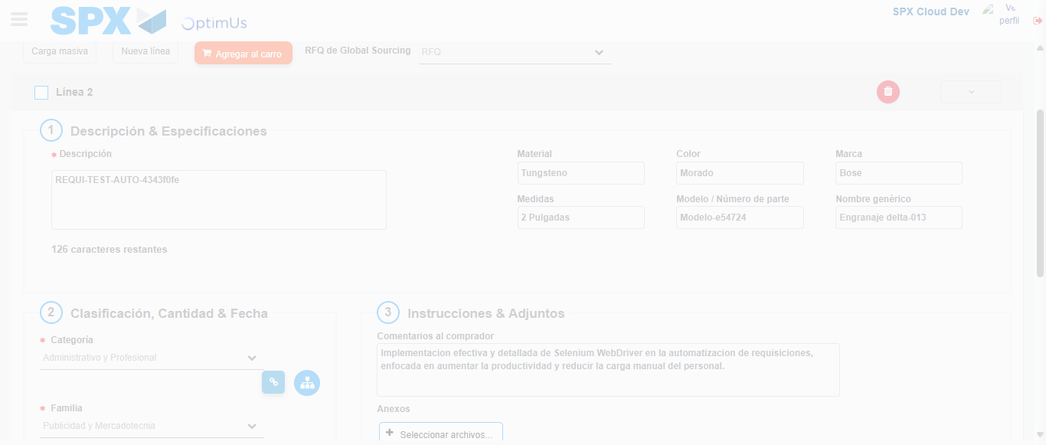Image file-name: QC_Testing-tc001_SPX_Dev5_Crear_Nueva_Linea_Requisicion_Spot_Tipo_Cobro_CC-nov. 28 2025, 09 55 06 a. m.

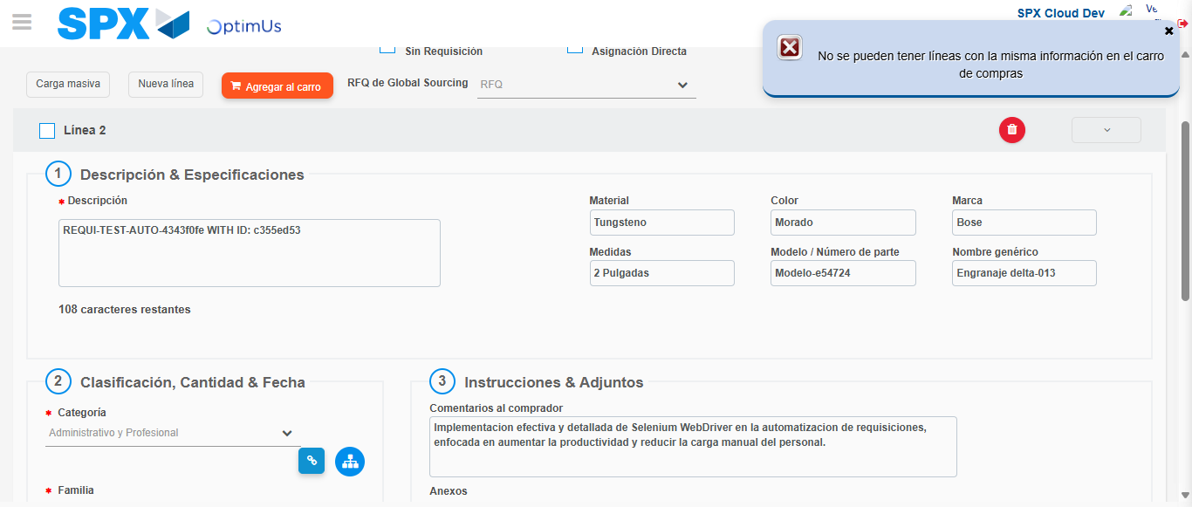Image file-name: QC_Testing-tc001_SPX_Dev5_Crear_Nueva_Linea_Requisicion_Spot_Tipo_Cobro_CC-nov. 28 2025, 09 55 07 a. m.

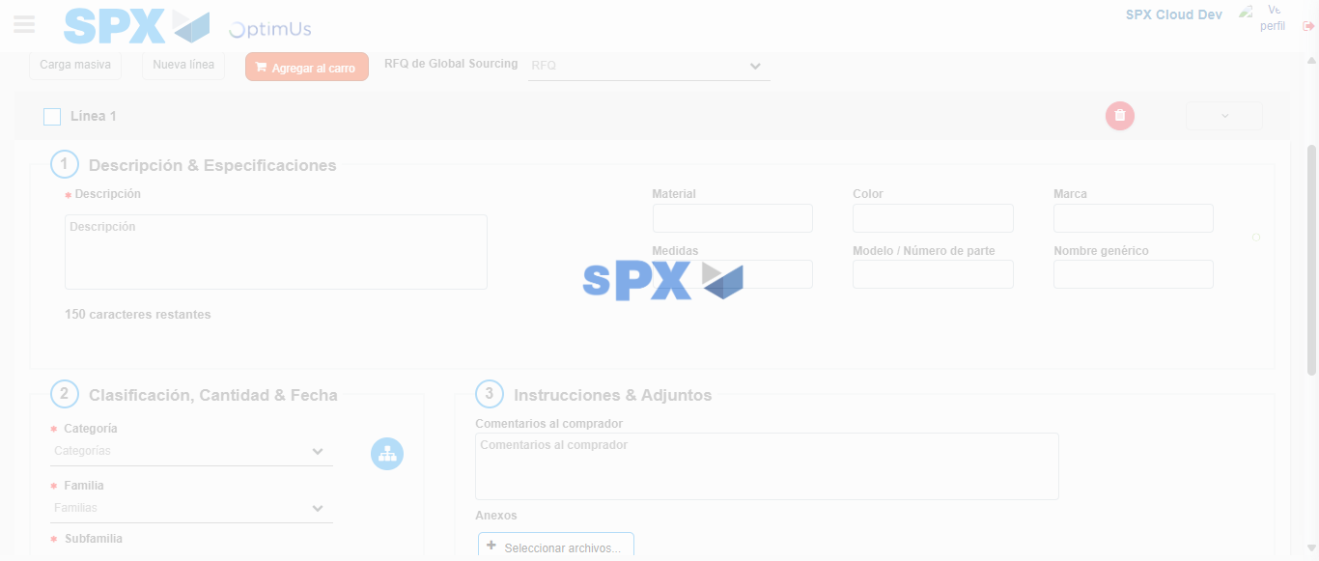Image file-name: QC_Testing-tc001_SPX_Dev5_Crear_Nueva_Linea_Requisicion_Spot_Tipo_Cobro_CC-nov. 28 2025, 09 55 12 a. m.

Step 5 - Select to Requisition: Requisition Correctly selected
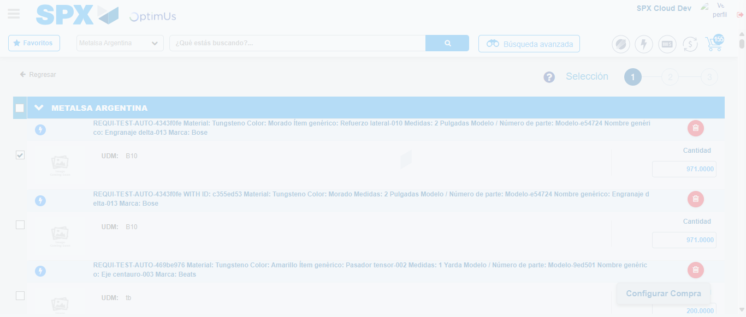Image file-name: QC_Testing-tc001_SPX_Dev5_Crear_Nueva_Linea_Requisicion_Spot_Tipo_Cobro_CC-nov. 28 2025, 09 55 25 a. m.

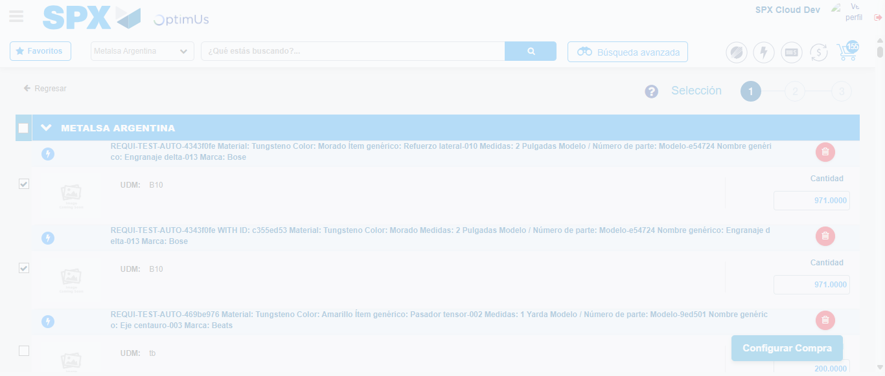Image file-name: QC_Testing-tc001_SPX_Dev5_Crear_Nueva_Linea_Requisicion_Spot_Tipo_Cobro_CC-nov. 28 2025, 09 55 26 a. m.

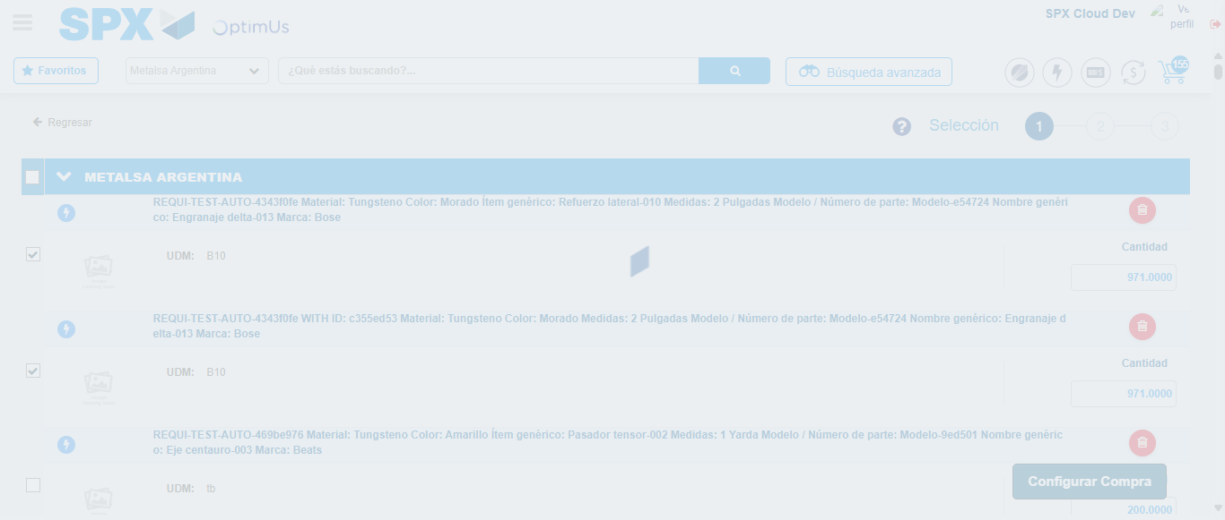Image file-name: QC_Testing-tc001_SPX_Dev5_Crear_Nueva_Linea_Requisicion_Spot_Tipo_Cobro_CC-nov. 28 2025, 09 55 30 a. m.

Step 6 - Select Type Account For Requisition: Type Account Correctly selected
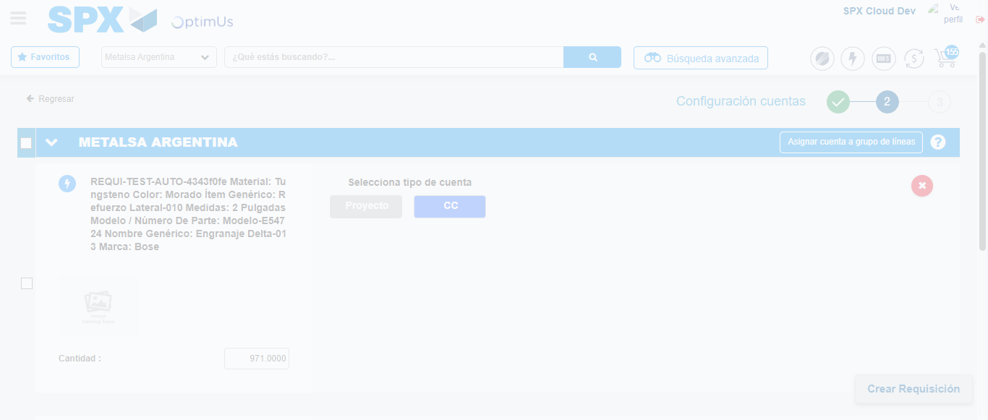Image file-name: QC_Testing-tc001_SPX_Dev5_Crear_Nueva_Linea_Requisicion_Spot_Tipo_Cobro_CC-nov. 28 2025, 09 55 33 a. m.

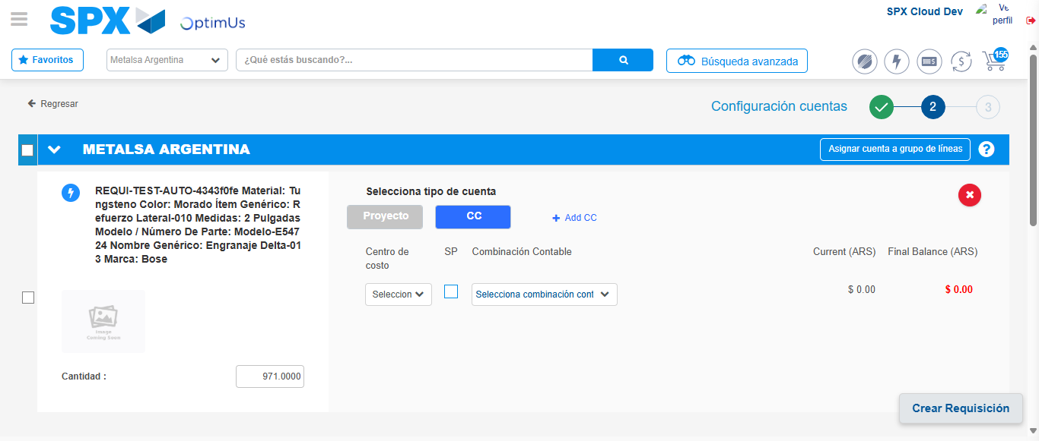Image file-name: QC_Testing-tc001_SPX_Dev5_Crear_Nueva_Linea_Requisicion_Spot_Tipo_Cobro_CC-nov. 28 2025, 09 55 36 a. m.

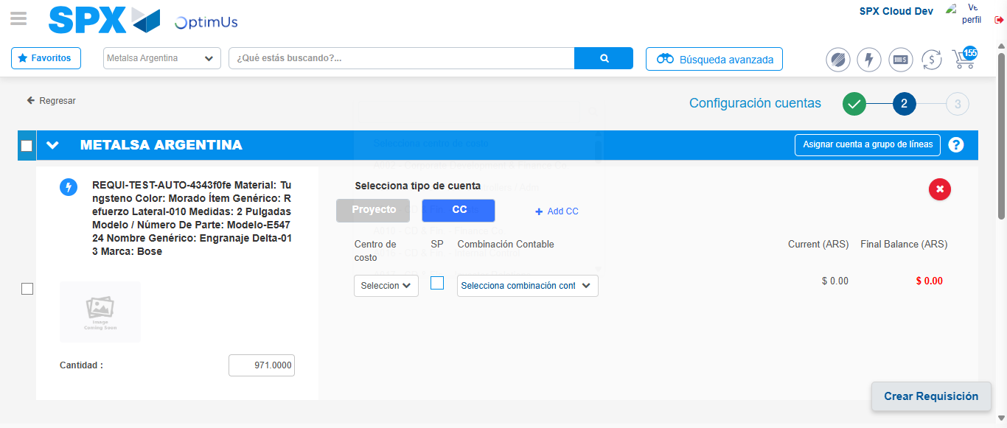Image file-name: QC_Testing-tc001_SPX_Dev5_Crear_Nueva_Linea_Requisicion_Spot_Tipo_Cobro_CC-nov. 28 2025, 09 55 39 a. m.

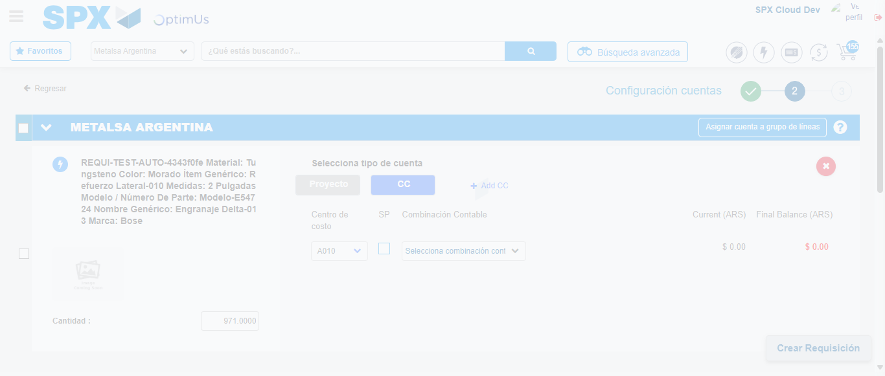Image file-name: QC_Testing-tc001_SPX_Dev5_Crear_Nueva_Linea_Requisicion_Spot_Tipo_Cobro_CC-nov. 28 2025, 09 55 40 a. m.

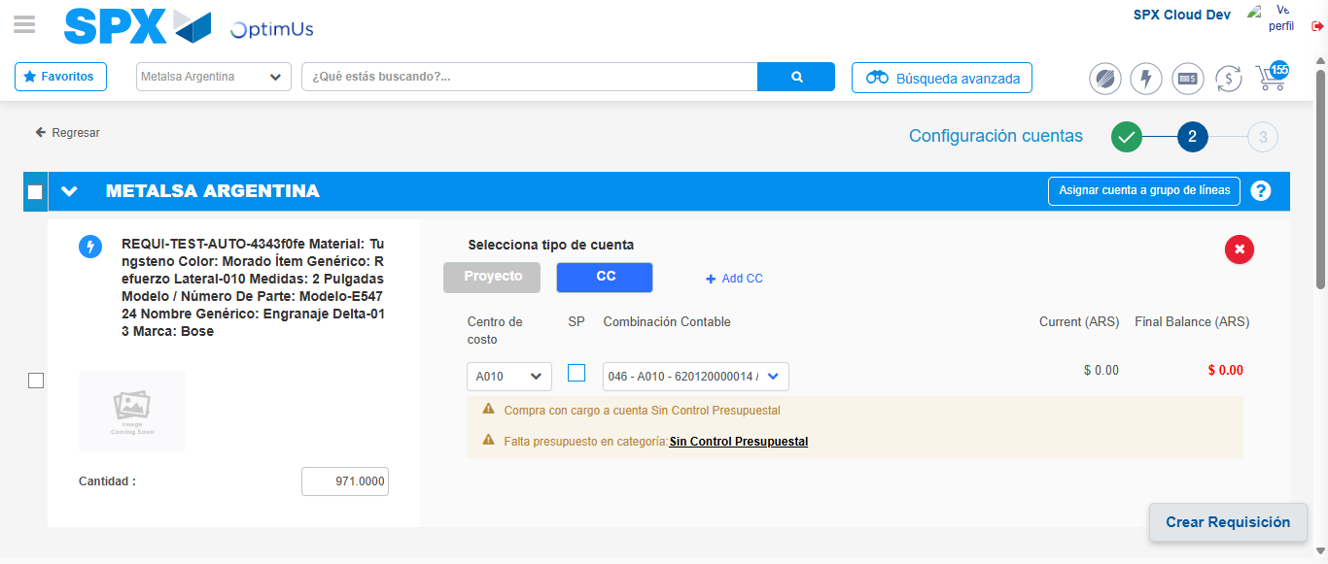Image file-name: QC_Testing-tc001_SPX_Dev5_Crear_Nueva_Linea_Requisicion_Spot_Tipo_Cobro_CC-nov. 28 2025, 09 55 43 a. m.

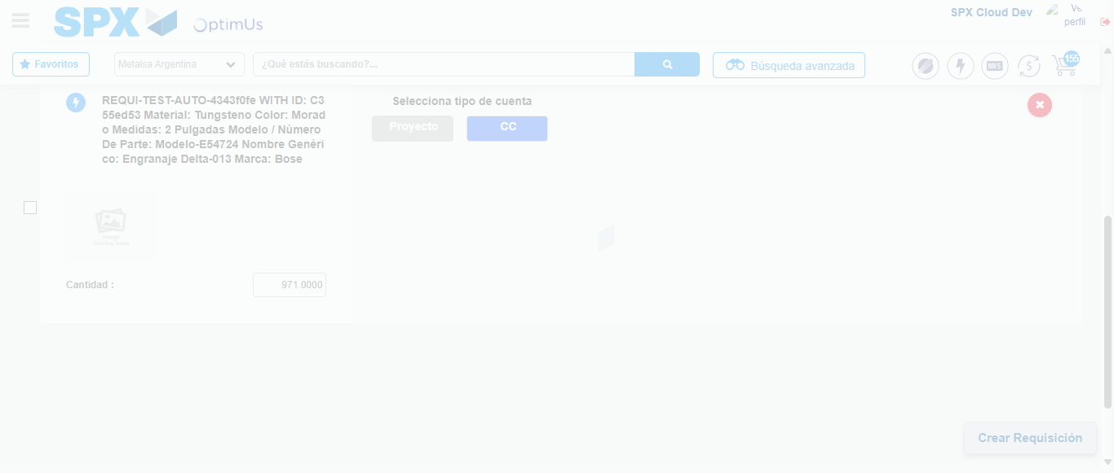Image file-name: QC_Testing-tc001_SPX_Dev5_Crear_Nueva_Linea_Requisicion_Spot_Tipo_Cobro_CC-nov. 28 2025, 09 55 50 a. m.

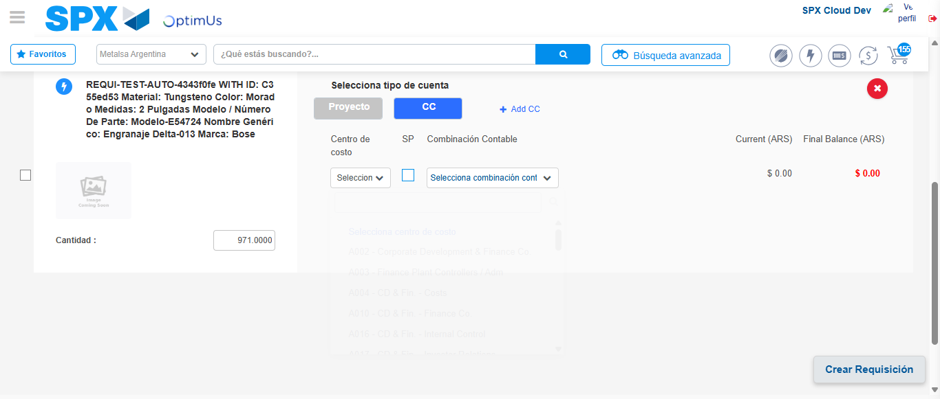Image file-name: QC_Testing-tc001_SPX_Dev5_Crear_Nueva_Linea_Requisicion_Spot_Tipo_Cobro_CC-nov. 28 2025, 09 55 53 a. m.

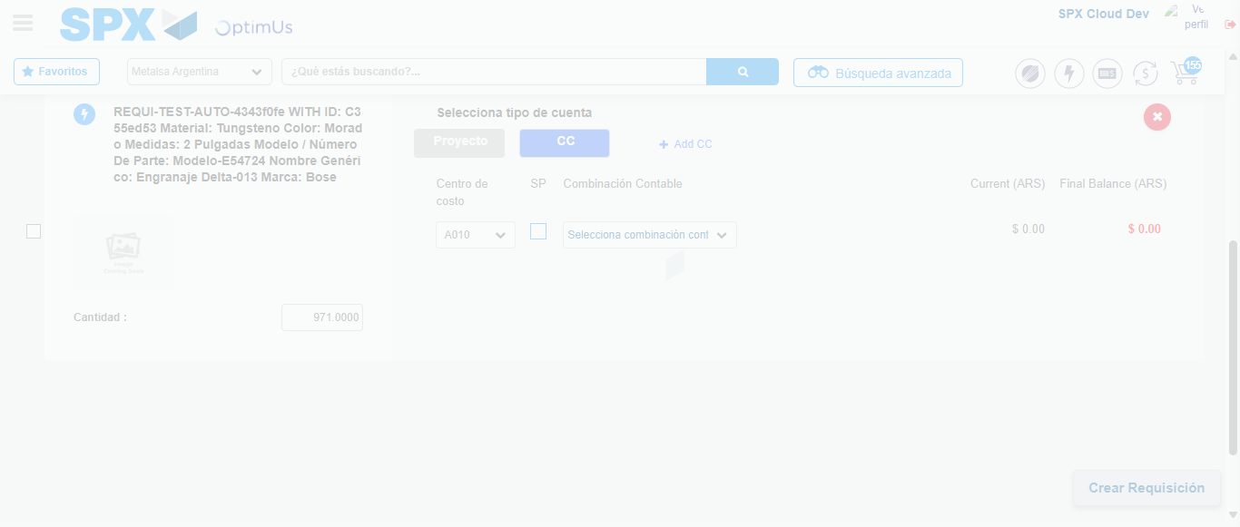Image file-name: QC_Testing-tc001_SPX_Dev5_Crear_Nueva_Linea_Requisicion_Spot_Tipo_Cobro_CC-nov. 28 2025, 09 55 54 a. m.

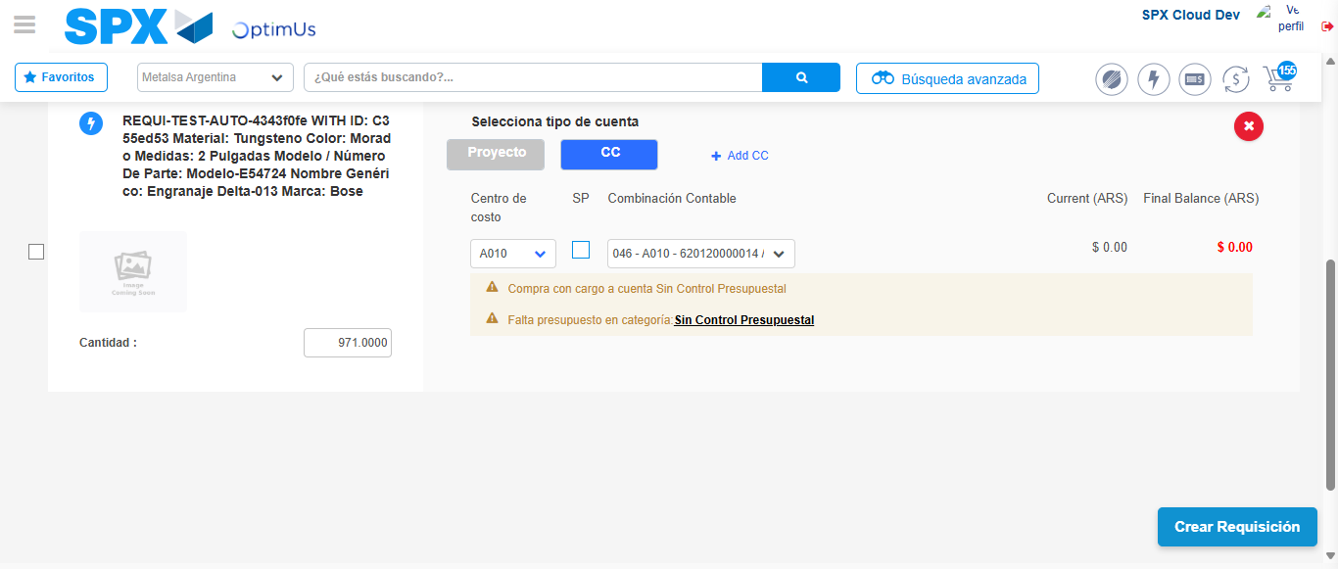Image file-name: QC_Testing-tc001_SPX_Dev5_Crear_Nueva_Linea_Requisicion_Spot_Tipo_Cobro_CC-nov. 28 2025, 09 55 57 a. m.

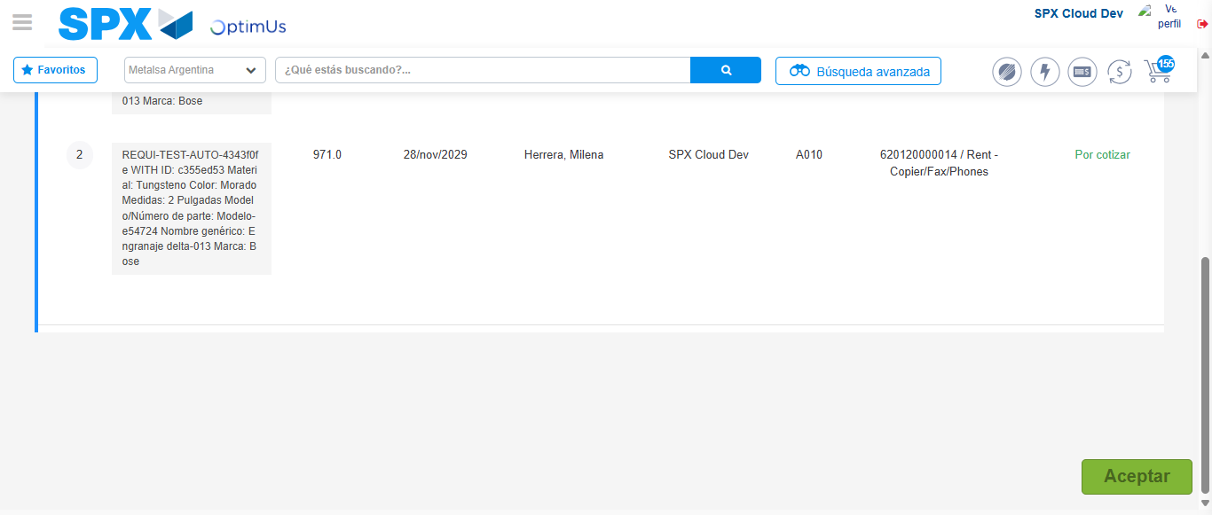Image file-name: QC_Testing-tc001_SPX_Dev5_Crear_Nueva_Linea_Requisicion_Spot_Tipo_Cobro_CC-nov. 28 2025, 09 55 58 a. m.

Step 7 - Accept to Requisition: Requisition Accepted
Image file-name: QC_Testing-tc001_SPX_Dev5_Crear_Nueva_Linea_Requisicion_Spot_Tipo_Cobro_CC-nov. 28 2025, 09 55 58 a. m.

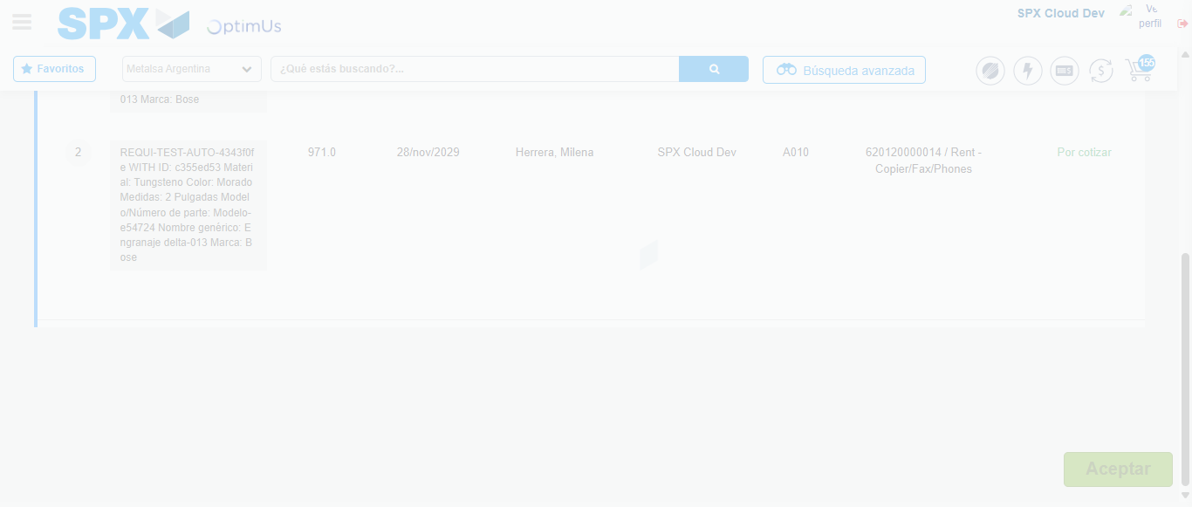Image file-name: QC_Testing-tc001_SPX_Dev5_Crear_Nueva_Linea_Requisicion_Spot_Tipo_Cobro_CC-nov. 28 2025, 09 55 59 a. m.

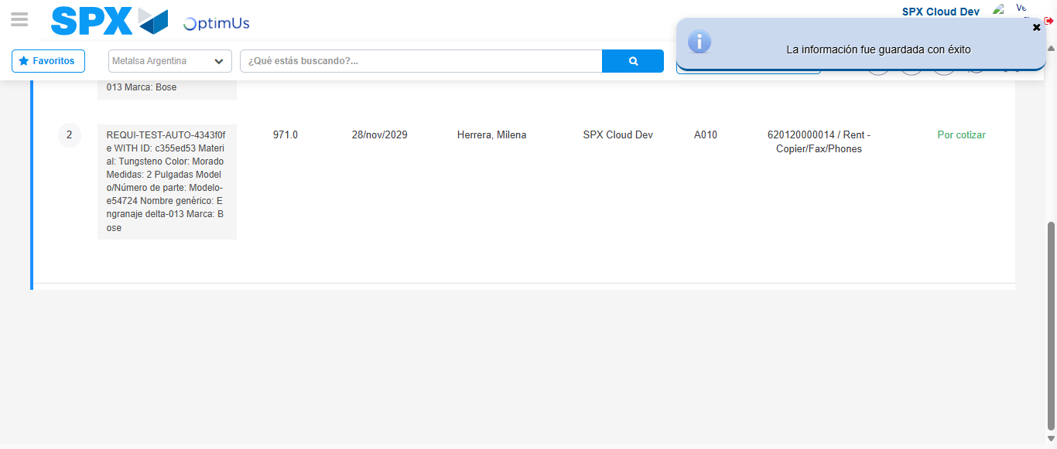Image file-name: QC_Testing-tc001_SPX_Dev5_Crear_Nueva_Linea_Requisicion_Spot_Tipo_Cobro_CC-nov. 28 2025, 09 56 02 a. m.

